Toronto East Chapter of OACETT - Chapter meeting

DATE: Friday. April.14.2023
Location: Scarborough Civic Centre, Councillors Chamber
Time: 6:00 p.m. - 9:00 p.m.
Chair: PASHA Mohammed, C.Tech, Chapter Chair

Present:

- Reg Grieco, C.E.T., Regional PASB Councillor
- Jose Vicente Catilo, C.E.T., Regional IETO Councillor
- Pasha Mohammed C.Tech, Chapter Chair
- Jayne Smith. C.E.T., Vice Chapter Chair
- Clive Banton C.E.T, Past Chapter Chair
- Ghassan Fayad C.E.T, Secretary
- Mazin Audeh C.E.T, Fellow OACETT, Chapter executive member
- Willie Perez C.E.T, P.Eng, Chapter executive member
- Sithambarapillai A Suresh C.Tech, Chapter executive member
- Kathryn Boir, Chapter and Program Advisor in OACETT
- Olivia Lun, C.Tech
- Kanthavannam Ilampooranan
- Cesar Pasquali, C.E.T.
- Eldho Alias, Student member
- Joye Manlangit , Associate Member
- Amey Kubal, C.Tech
- Glenn Velasco, Associate Member
- Neha Sharma, Student member
- Sailaivasem Vettivelu, C.E.T.

Distribution:
- All present
- Steve Barnes C.E.T, Fellow OACETT, Regional Secretory Treasurer
- Len Canzius C.E.T, Chapter Treasurer
- Chun Mei Yuam C.Tech, College Liaison
- File

Meeting Chaired by Pasha Muhammed the chapter chair

The meeting started with a CPD approved presentation at 6:15 PM and lasted to 7:40 PM: The presenter was Nicolas Morgan from Morgan Solar and the title of the presentation was "A Window to Net-zero Buildings: Morgan Solar Energy Blinds"

Summary of The presentation
1. Summary of Government of Canada EPWC Program and goals
2. Primer on Building Efficiency and Sunlight
3. Current Solutions in the market
4. Concerns for embodied Carbon
5. Overview of Morgan Solar Energy Blinds
a. Discussion of our product and current status
b. Energy Blinds Case Study
c. Building Analysis Case Study - How to recognize opportunities for improved energy efficiency
6. The role of the innovative Morgan solar energy blinds in generating electricity

After the presentation we took a break time then we started the ACM meeting at
The meeting started with the agenda:

1. Annual Chapter Meeting welcome remarks, call to order and approval of Agenda
The Secretary of Toronto East Chapter, Ghassan Fayad, welcomed everyone and thanked them for joining the 2023 Annual Chapter Meeting (ACM), and took a moment to acknowledge the land of Scarborough as a traditional territory of many nations.
The secretary reminds the members in attendance that only Certified Members in good standing are entitled to vote.
The Secretary called the annual chapter meeting of the OACETT Toronto East Chapter to order at 8:10 PM on April 14, 2023 with QUORUM PRESENT.

The Agenda of Toronto East Chapter ACm on April.14.2023 is as follows:
1. Welcome Remarks
2. Approval of Agenda
3. 2022 Chapter Year in Review
4. Chapter Finance Statement year ending December 31, 2022
5. IETO Highlights
6. PASB Highlights
7. 2022-2023 Chapter Election
8. Upcoming Meetings and Events
9. Q&A

Approval of Agenda:
The secretary put Motion to approve 2023 Toronto East Annual Chapter Meeting Agenda.
The motion moved by Clive Banton, C.E.T., Seconded by Jose Vicente Miguel, C.E.T. After the approval resolved that the agenda for the OACETT Toronto East Annual Chapter Meeting of Members for April 14, 2023 be approved as amended.
Everyone was in favor and the motion was carried.

2. 2022 Chapter Year in Review and introduction about OACETT and the chapter
- The secretary reviewed the following:
  - The names of the 2022-2023 executives committee with their OACETT's designated titles
  - The individual head shots of some of the chapter executives, and pictures of the chapter executives and their families
  - Who we are as OACETT and what its roll from certification to conferring engineering designations, in addition to the number of its members, its regions and chapters
  - The chapter responsibilities
- Then, he moved to the chapter year in review from March 2022 to April 2023 including all the chapter events. The review included, as well, pictures from August.14. 2022 joint picnic event with Toronto Central Chapter, in addition to the chapter's executive's dinner at the end of 2022, and the chapter meeting on March 03 2023.
- The presentation included celebrating the chapter's members who has been members in OACETT for 10, 24, and 40 years.
3. Chapter Finance Statement year Ending December 31, 2022
- Len Canzius the treasurer of the chapter provided Toronto East Chapter TD banking statement for 2021. Jose Catilo, IETO councillor presented the Annual Statement of Revenue and Expenditure for the year end Dec.31.2022:

Date Description Check/Debit Deposit/Credit Balance Remarks
Dec.31.2021 Balance Forward $5,622.67 Balance Forward from 2021
Jan.31.2022 Monthly Plan Fee $4.95 $5,617.72
Feb.28.2022 Monthly Plan Fee $4.95 $5,612.77
Mar.22.2022 Check # 526 $1000.00 $4,612.77 Centennial College(Fletch.Fo.
Mar.31.2022 Monthly Plan Fee $4.95 $4,607.82
April.20.2022 Check#527 $20.79 $4,587.03 Clive Banton ACM 2022 Exp April.29.2022 Monthly Plan Fee $4.95 $4,582.08
May.24.2022 Capita Grant $4.95 3,480.31 $8,057.44 Capita Grant 2022
June.30.2022 Monthly Plan Fee $4.95 $8,052.49
July 29 2922 Check#528 $750.00 0 $7,302.49 George Fletcher (OACET
July 29 2022 Monthly Plan Fee $4.95 $7,297.54
Aug 11 2022 Check#529 $500 $6,797.54 Christmas Gift Cards
Aug 11 2022 Check#530 $252.80 $6,544.74 Picnic 2022 (Mazin)
Aug 22 2022 Check#533 $72.32 $6,472.42 Picnic 2022 (Willie Perez)
Aug.26 2022 Check#531 $306.00 $6,166.42 Picnic 2022 (Clive Banton)
Aug 31 2022 Monthly Plan Fee $4.95 $6,161.47
Sep 06 2022 Check#534 $22.85 $6,138.59 Stamps (Len Canziuz)
Sep 08 2022 Check#535 $89.76 $6,048.83
Sep 29 2022 Monthly Plan Fee $4.95 $6,043.88
Oct 31 2022 Monthly Plan Fee $4.95 $6,038.93
Nov.30 2022 Monthly Plan Fee $4.95 0 $6,033.98
Picnic 2022 Jose & Dep
Dec 19 2022 Check#532 $108.28 $30.09 $5,925.70 of $530.09 From
Toronto Central
Dec.28.2022 Check#537 $626.07 $5,829.72 Christmas Dinner (Jose)
Dec 30 2022 Monthly Plan Fee $4.95 $5,824.77 Year End Balance 2022

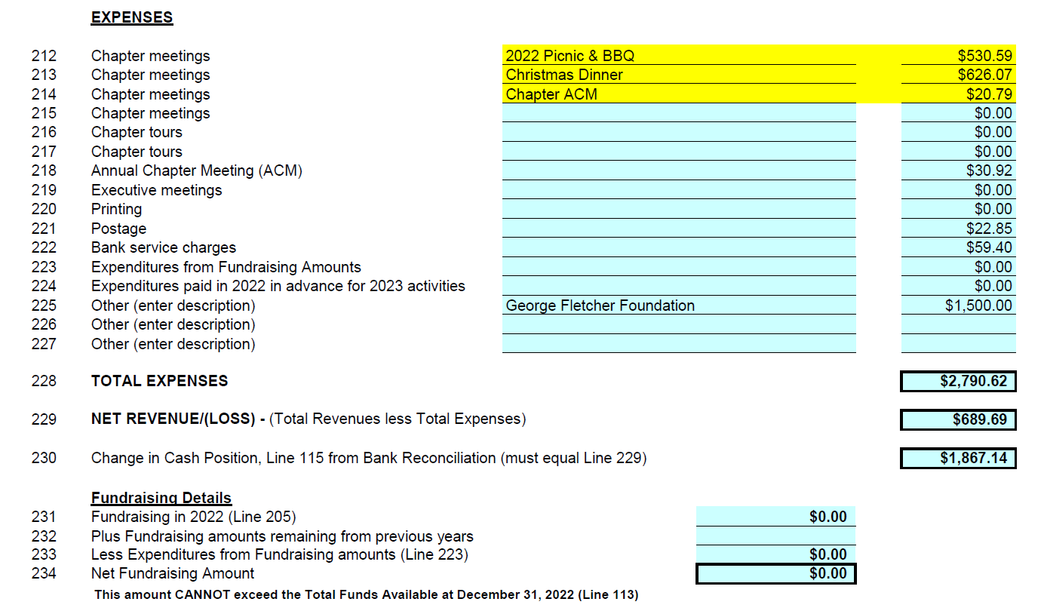

Motion to approve Chapter Finance Statement year ending December 31, 2022
Moved by Pasha Mohammed, C.Tech., Seconded by Ghassan Fayad, C.E.T. Resolved that the financial statement for the 2022 OACETT Toronto East Annual Chapter Meeting of Members for April 14, 2023 be approved as amended.
The motion was carried.

4. IETO Highlights
Jose Castilo the IETO Councillor for Toronto Region presented the IETO Highlights:
MEMBERS TO DATE AS OF APRIL 1, 2023 | THIS MONTH | LAST MONTH
Certified Members | 16,290 | 16,119
Associate Members (including Student Members) | 4,859 | 4,824
TOTAL | 21,149 | 20,943

  - The Ontario Fairness Commissioner’s office has been very impressed with OACETT’s alternative to demonstrating Canadian standards and codes without the need for one-year Canadian work experience. OACETT had created the Internationally Educated Professional Practice Exam (IEPPE) to help newcomers gain employment quicker by administering this exam for those who needed Canadian experience. Kudos to Barry Billing and his team for their tireless efforts.
  - CPD Committee: The CPD committee and staff are working on revising the CPD program to make it more objective, fair and easier to measure.
- Education and Exam Committee: The committee has been meeting regularly every four to six weeks for revisions to the PPE/IEPPE. New version for implementation in May 1, 2023.
- 2023 Business Plan - Technology Stewardship
Establish a partnership with Engineering Change Labs in the creation of an OACETT-specific Technology Stewardship
Practice Program (TSPP) focused on the needs of engineering technology professionals.

5. PASB Highlights
Reginald Grieco, the Toronto Regional PASB Councillor presented the PASB updatedets for ACM:
- Corporate Outreach
We are currently recruiting to fill the vacancy for the position of Corporate Outreach and Membership Services. We have new corporate partners in the works,
- College Outreach
- We have placed the order for two digital kiosks to support the college outreach efforts. These kiosks are part of a pilot program to gauge the success of having a permanent piece of technology in a college to raise awareness and potentially automate student membership.
- OACETT is also planning to roll out a free student membership pilot program in six colleges to recruit students and increase membership growth. The pilot project will last for 5-6 years as we track the conversion from student to associate member and then to certified. The goal is to verify if increasing the pool of applicants by making student applications free will increase conversion to full membership.
- In January, we received 82 student applications, up 7 (9% increase) from last year.
- On another positive note, we have attended in-person events at Humber and Mohawk College and presented in person at Durham, Canadore, and Humber College. As we move into March and April, we will be on campus at Centennial, Conestoga, Confederation, Durham, Fanshawe, Humber, Mohawk, Niagara, Northern, Seneca, and St. Clair colleges, most of which will be conducted with the support of the local chapter. We continue to conduct virtual presentations, including recent career events at Fleming and Conestoga Colleges. Also, we provide weekly webinars for college students. We anticipate seeing an increase in student membership applications with the transition back to on-campus events and presentations this semester.
- Fourteen virtual webinars have been conducted since the last Council meeting in November 2022 (7 for college students and 7 for IEPs).
- We will have our first Student Taskforce meeting in April with the Chair, our Student Representative on council Charles Gilmer.

IEP Outreach

We continue to host weekly IEP webinars in addition to our supporting webinars to our community partners, such as TDSB, ACCES Employment, YMCA/YWCA, and Newcomer centers. In April, we will be sending out save-the-date information for our 2023 IEP, which will take place in the fall event, along with updated IEP brochures to all contacts and community partners.

OACETT Annual Conference and Awards Gala

The upcoming conference will take place in Niagara at the Hilton Falls from June 1-3. The awards gala has been merged into the President’s Dinner at the annual conference. The conference theme is “Unlocking the Strength of Partnerships”.

Membership Packages
OACETT will be updating he student, associate and certified membership packages.
Generally, the student package consists of welcome letter, a quick fact sheet on PPE and IPPE, certification timelines, etc. The goal is to make the packages more appealing and add more information about the process of certification and a page of on benefits that are currently missing as well as a promo item.
The associates’ package has more content including the admissions letter, CPD fact sheet, code of ethics. Quick facts and PPE and IPPE This version will be simplified and will include a benefits page
All welcome packages will be printed and mailed to members and will also be available in electronic version. The electronic version will include onboarding/promotional video highlighting the benefits and other important information.

OACETT & CTEN Website Update
The website and CTEN project is moving forward with a scheduled release in early April. Content is currently being uploaded and tested. Chapters will have individual landing pages. All content will be provided from chapters. The new chapter pages will be standardized and edited/changed by head office. Although chapters do lose some functionality, the new pages will have an updated look and feel and a calendar of events will be updated by the Chapter and Program Advisor.

Marketing and Communications

Advertising
PAS is working on multiple advertising campaigns to increase awareness for OACETT, its certification, and the profession to key stakeholder segments

Continuing Professional Development
- The first of the 2023 CPD offerings rolled out in late January.

Staff are currently connecting with new and old providers to create a dynamic array of offerings, all at reasonable prices. An emphasize on courses from a more broad range of disciplines will be considered.

CPD will be offered in conjunction with awareness days like “International Woman’s Day” and events such as the CANECT conference and CSC Building Expo.

Government Relations
OACETT has been very active with our government relations firm working on initiatives to deepen our relationships with key government ministries
Ministry of Municipal Affairs and Housing Consultation
During the Ministry of Municipal Affairs and Housing engagement sessions in 2021 and 2022, there was an exploration of ways to transform Building Code services. Several stakeholders, including OACETT, recommended reviewing the provincial qualification program for practitioners.
Ministry of Labour, Immigration, Training and Skills Development
Our outreach with the Ministry of Labour, Immigration, Training and Skills Development is bearing fruit. The recent visit to the Ministry with a member to discuss how OACETT certification reduces barriers for new Canadians has resulted in the Ministry reaching out to OACETT to be part of their "Better Life Campaign."

6. The importance of volunteering
The Secretary explained the following highlights:
1. Expand your professional network
2. Skill Development
3. Boost your career options
4. Earn continuous professional development (CPD)
5. Make Difference
6. Discover your strengths and talents

7. 2022-2023 Chapter Election

Motion to dissolve current Toronto East chapter executive committee.
Moved by Clive Banton, C.E.T., Seconded by Pasha Mohammed, C.Tech.
Resolved that the Toronto East Chapter of the Ontario Association of Certified Engineering Technicians and Technologists 2022-2023 chapter executive be dissolved.

CARRIED

Election of the Toronto East Chapter for 2023-2024
Chapter Chair | Pasha Mohammed, C.Tech.
Vice-Chair | Jayne Smith, C.E.T.
Past Chair | Clive Banton, C.E.T.
Secretary | Ghassan Fayad, C.E.T.
Treasurer | Lennox Canzius, C.E.T.
College Liaison | Chun Mei Yuan, C.Tech., rcji
College Liaison | Olalekan Odunaike, C.Tech.
College Liaison | Neha Sharma
Women in Tech Rep | Neha Sharma
Women in Tech Rep | Jayne Smith, C.E.T.
Women in Tech Rep | Olivia Lun, C.Tech.
Chapter Executive Member | Sithambarapillai Suresh, C.Tech.
Chapter Executive Member | Willie Perez, C.E.T., P.Eng.
Chapter Executive Member | Sailaivasan Vettivelu, C.E.T.
Chapter Executive Member | Muhammad Qadeer, C.Tech.
Chapter Executive Member | Glenn Velasco
Chapter Executive Member | Amey Mohan Kubal, C.Tech.
Chapter Executive Member | Marcelino Astillero, C.E.T.

Motion to approve the OACETT Toronto East Chapter for 2023-2024 Chapter Executive
Committee
Moved by Jose Vicente Miguel, C.E.T. , Seconded by Pasha Mohammed, C.Tech.
Resolved that the 2023-2024 Toronto East chapter executive committee of the Ontario Association of Certified Engineering Technicians and Technologists be accepted as presented.

CARRIED

8. Upcoming Meetings and Events

No comments
9. Q&A
No Quistiones
10. Closing
Call for a motion for Meeting Adjournment - Clive Banton, C.E.T

Pasha Mohammed the chair adjourned the end of the meeting, and thanked everyone for attending

